A word about the tests you just took.....

In order to give our patients the finest service anywhere, we use a number of diagnostic tests to help locate and correct nerve interference around your spine. This technology is the finest around, and we are pleased to announce that we are one of the few providers around to offer you this service.

Our focus as Chiropractors is the function of your Central Nervous System(CNS). There are 3 primary branches of your CNS. One of them, the sensory nervous system, is probably what brought you in to our office. This is the branch that feels the pain. The more important branches of the CNS are the autonomic (controls your organs) and motor nerves (moves your muscles).
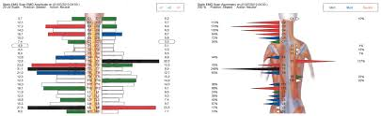
The thermal scanner (wheel) measures the difference in temperature on each side of your spine. Your skin temperature is controlled by the autonomic system. The autonomic system regulates the various functions of your body that you don’t have to think about: heart rate, breathing, organ function, skin temperature and much more.
In other words, IT’S VERY IMPORTANT TO YOUR HEALTH.
.
According to published scientific research from Johns Hopkins University, if your results show that one side is hotter than the other, it is an indication that your autonomic nervous system is not working correctly. A subluxation can cause this dysfunction.

The next test, the Surface EMG (SEMG), measures small amounts of electrical activity. The more your muscles contract, the more electrical
activity they generate. Our scanner measures this activity in microvolts or
one millionth of a volt. The results give us 2 reports, amplitude (if your
muscles are pulling too tight or not tight enough) and asymmetry (comparing one side of your paraspinal muscles to the other side).
Using these technologically advanced tests along with our hands-on palpation will help us determine the root of your problem and aid us in giving you the best care possible.

If you have any questions at all, please do not hesitate to ask the doctor. We are here to help you in any way we can...

